**http://mpv-au.vlabs.ac.in/modern-physics/Determination_of_Plancks_Constant/experiment.html**

**4. Planck’s Constant**

**Objective:** To determine Planck's constant using Light Emitting Diode (LED).

**Apparatus used: Trainer kit,** Super bright LEDs and  variable power supply (0-5Volt)

**Theory and formula used:** In this experiment, we are using light emitting diodes (LEDs) to measure Planck’s constant. LEDs are semiconductor diodes that emit electromagnetic radiation in optical and near optical frequencies, when operated in forward bias, above a minimum threshold voltage. In this condition, an electron hole pair is created in the diode and thus current starts flowing. Above the threshold value, the current increases exponentially with voltage. A quantum of energy is required to create an electron hole pair and this energy is released when an electron and a hole recombine. In most diodes, this energy is absorbed by the semiconductor as heat, but in LEDs, this energy produces photons with frequencies (or wavelengths) in the visible range. The energy of a photon is related to its wavelength as:

**E = h*ν* = hc/λ................(1)**

By using semiconductors of specific band gap, the wavelength emitted by the LED can be varied and thus the light emitted by LEDs may span a range of discrete wavelengths. When the applied voltage is just sufficient to supply the energy required to create a electron hole pair in a semiconductor, the LED will just start glowing. This voltage is called threshold voltage or turn-on voltage (V0) and depends on the band gap of the semiconductor. The relation between the wavelength emitted by the LED, λ, and the turn-on voltage, V0, is given as

**hc/λ = eV0 or h = eV0λ/c....................(2)**

Where, h is Planck’s Constant (6.625 х 10-34 Js), e is the electronic charge (1.6 х 10-19 C), V0 is threshold voltage, λ is wavelength emitted by the LED and c is the velocity of light (3 х 108 m/s).

If the turn on voltage V0 is measured for several diodes which emit different colours (i.e., different wavelengths) and a graph is plotted between V0 and 1/ λ, it should be linear (Figure 1). The slope of this graph is given by

**Slope = AB/BC = *h*c/e. Or, **

Using the known values of c and e, we can compute h.

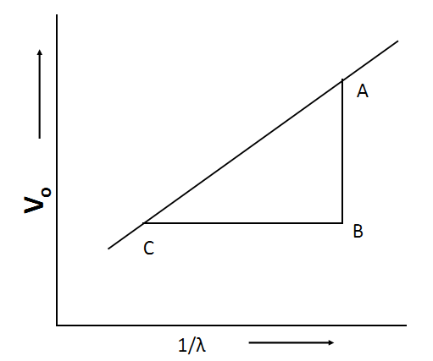

Figure 1.

**Circuit Diagram:**

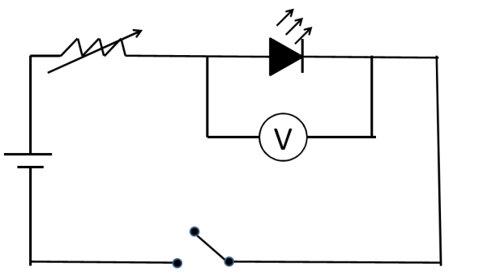Figure 2: Circuit diagram for Planck constant set up

**Procedure:**

**1.** Take the Planck's constant Determination Trainer. Make the connections as shown in Figure 3.

**2.** Connect + ve terminal of DC power supply to + ve terminal of DC voltmeter and + ve terminal of any one LED.

**3.** Now connect - ve terminal of DC power supply to - ve terminal of DC voltmeter and -ve terminal of LED.

**4.** Set the range of DC voltmeter at 20 V.

**5.** Connect the mains cord and switch ‘On’ the power supply.

**6.** Now vary the DC voltage slowly by variable resistance pot and see the LED connected in circuit.

**7.** When the LED is just starts to emit light, note the value of applied voltage using DC voltmeter.

**8.** Now switch ‘Off’ the DC power supply and break the LED connection.

**9.** Again make same connection for another colour of LED.

**10.** Now repeat the step 8 and 9.

**11.** Repeat above experiment for different colours of LEDs.

**Observation Table:**

|  |  |  |  |  |
| --- | --- | --- | --- | --- |
| S.No. | Colour | Wavelength (λ) | 1/ λ  (m-1)x 106 | V0  (Volts) |
| 1 | Blue | 470nm | 2.127 | 2.615 |
| 2 | Green | 510nm | 1.961 | 2.434 |
| 3 | Yellow | 570nm | 1.754 | 2.178 |
| 4 | red | 650nm | 1.538 | 1.908 |
| 5 | Infra Red | 700nm | 1.428 | 1.121 |

**Calculations:**

Plot a graph between V0 and 1/ λ. It will be a straight line as shown in Figure 1. Find the slope:

Slope = AB/BC = hc/e

**Or, **

Exp. value of the Planck constant = ………………………….Js

**Results:**

Planck’s constant is………………….… Js

Standard value: 6.625 х 10-34 Js

**% Error:** Percentage error = () 100

**Precautions and sources of error:**

1. Make sure that all the connections are tight.

2. Note the threshold voltage carefully, when the LED just starts glowing.

3. Make sure that LED is in the forward bias.

4. Handle the equipment carefully.

1nm=10-9 M

470nm =470x10-9m

1/m=1/470x10-9m

=1x10+9/470 m

=1000 x106/470m